Unofficial Template for APS Manuscripts Prepared Using Microsoft Word
Revised 0/0/0000 00:00:00

Eric L. Michelsen¹ and Second Author²
¹University of California, San Diego, Department of Physics
9500 Gilman Dr. MS-0424 SERF-317, La Jolla, CA, USA 92093
e-mail address: emichels@physics.ucsd.edu
²Some other Institute, Some Department
Some address and mailstop, city, state/province, country postal-code
This unofficial template may be useful in preparing text for APS papers, or not. It is completely unofficial, and not endorsed by APS in any way. I post it in the hope that it will save people some time, but cannot guarantee its use for anything, including APS submissions. Consult the APS web pages for current information, as this template, by itself, is wholly inadequate to prepare a paper. A February 2012 email from APS states: “APS does not provide Word technical support to authors, nor do we provide a template for preparing a paper... .” Separately, note that ArXiv requires, if using Word, a Word 2007 *.docx file, which you can easily make from this if you have Word 2007.

Keywords: MS Word, Template, choose from APS keyword list
PACS: 95.55.Sh, 93.90.+y, 13.15.+g

- Introduction
This template may be useful in preparing text for APS papers, or not. It is completely unofficial, and not endorsed by APS in any way. This template started from portal.fi.itb.ac.id/aps2009/files/aps2009.dot, a template for APS 2009 proceedings. However, I have modified it according my reading of the APS manuscript preparation web pages at https://authors.aps.org/ESUB/ [1], https://authors.aps.org/esubs/guidelines.html [2], and my observation of a recent Phys. Rev. D paper. Note that [2] appears to contradict itself in places, and other web pages within the APS site contradict each other (e.g., https://authors.aps.org/esubs/faq.html#word).
Separately, note that ArXiv requires, if using Word, a Word 2007 *.docx file, which you can easily make from this if you have Word 2007.
I am new to the APS format, and this is my first attempt, so it is likely to have some mistakes. I post it in the hope that it will save people some time, but cannot guarantee its use for anything, including APS submissions. Consult the APS web pages for current information, as this template, by itself, is wholly inadequate to prepare a paper. Please send corrections for this template to me.
[2] states, “Manuscripts submitted to the journals must contain original work which has not been previously published in a peer-reviewed journal, and which is not currently being considered for publication elsewhere.”.
Remember that the formatting of your manuscript is largely irrelevant to its final appearance in the journal, since they will completely reformat the text before publication. However, this template helps you see approximately how it will look, and helps with things such as references.
While editing, you should choose “Normal View,” and set _Tools_, _Options_, |View|, Style area width to 0.8” so you can see the paragraph styles on the left. I have only viewed this template on Windows, but it should be largely portable to Mac. Use “Print Layout View” for a better view of how your draft looks on a page.
This template is primarily text formatted with Word paragraph styles that are defined to provide appropriate formatting. Using Word styles is important, because it allows formatting changes to be quickly applied to the entire document by simply modifying the style. Authors can directly use the basic styles defined within this template. However, authors are free to create their own styles, and add them to this template.
Following are examples of how to cite references.?? Since the first helical nanotubes of graphitic carbon were fabricated interest has focused on quasi-one-dimensional nanostructured materials [1], especially those made of carbon and silicon [2]-[4]. Silicon nanowires (SiNWs) have been synthesized by both physical and chemical vapor deposition (CVD) [5]-[12].
Example of writing Latin names appears in the following sentence. Some cultivar C. annuum are not spicy, but all cultivar C. frutescens are spicy [13].
- How to Use This Template
First, change the header to have your article title on the left, and your target journal on the right
You choose your section titles as you see fit.
In Windows, to use this template, save this file to ‘aps.dot’ in a convenient directory. Then, just double click on ‘aps.dot’ in any file explorer (such as Windows Explorer). This creates a new Word document from the template. You can then “Save As” the document with a new name.
To attach this template to an existing Word document:
- Open the document in Word.
- Select _Tools_, _Templates_, [Attach].
- Browse to this template file (e.g., aps.dot).
Once the document is attached to the template, while editing your document, you can choose a paragraph style from the drop-down box typically located in the upper left corner of Word, below the main menu.
Use SHIFT-F9 to see the coding of fields, instead of their results. Use the [¶] button to see hidden formatting marks, like spaces, tabs, and returns.
- How to Use Styles
It is very important to code the correct Word Style for each paragraph, so that you can change the style once, and every relevant paragraph will instantly be updated. To use styles, authors place the cursor in a paragraph they want to format, click down-arrow in the Style dropdown-box (typically upper left corner of Word), then click the style you want. The following explains how to use each style:
- The manuscript title uses style Title-article. Usually you can just overwrite the title supplied by the template. After applying this style, the template automatically shows style author when the authors press ↵ (Enter button) at the end of title.
- Use style author to create the author’s names. Again, you can usually just overwrite the template.
- Author’s Institution and address are created using style Affiliation.
- Abstract content is created using style Abstract.
- Section and subsection are formatted using Section Title.
- Normal text is formatted using style Normal.
- Figure captions use Figure style. However, the figure graphic uses picture style, which is centered.
- References, Acknowledgement, and Appendix are created using style Section Title.
- References are formatted using style ref.
- Numbered lists use style Numbered.
- Bullet lists use style bullet.
- Acknowledgements use style Section unnumbered.
- Equations
Equations should be encoded in MathType, and look like this:
(1)
You number equations and reference them just like references and citations: equation (1) is an integral. You can put short, unnumbered equations inline: . [2] states, “Use Design Science's MathType equation editor rather than Word's built-in equation editor when creating all items of a mathematical nature such as individual math symbols, Greek letters and other special characters not found on the keyboard.”
- Figures
If your manuscript contains figures, they are typically placed in one column. A large figure might span two columns.
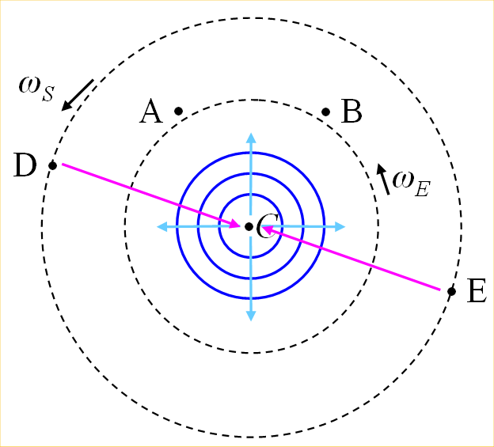
FIG. 1. (Color online) A central clock, orbited by one or more clocks. Figure captions use Figure style. The figure image itself uses picture style.
[2] states:
- “Since the figures will not appear as color in print, authors must begin figure captions with "(Color online)" as an alert to readers of the print journal.”
- “the printed size of the figure should be as close as possible to the final size to appear in the journal - the standard is 8.5 cm maximum width for one column.
- any resolution-dependent graphics should be drawn with at least 600 dots per inch (dpi) resolution for pure or mixed line art, and at least 264 dpi for color or halftone images.
Since one column is 3.25 inches wide, a 600 dpi figure should be 1950 pixels wide. A 300 dpi figure would be 975 pixels wide. [2] states, “For all REVTeX, LaTeX, Plain TeX and MSWord (re)submissions, the preferred format for figures transmitted electronically is PostScript or Encapsulated PostScript. Photographic images should be submitted as high resolution JPEG or PNG files. All figure files pertaining to a manuscript should have the same format,” and “N.B. Your MSWord file must still contain your figures, i.e., it is necessary to submit your figures twice.” [2] states, “Each figure file should be described as such and must have a number....” I suggest your separate figure files should have obvious names, such as “fig1.eps”, “fig2.eps”, etc.
[2] states, ‘MSWord, PostScript, and PDF files containing figures are described as "text+figs",’ and “Do not (re)submit MSWord files with embedded objects.” I assume this means do not submit with embedded powerpoint slides, etc. You must include any *.png and similar files in the Word manuscript.
- Conclusions
With this unofficial template, we hope authors can prepare their manuscript easily. This template is not endorsed by APS in any way, and may contain errors. For some formats, such as Table and hierarchical lists, authors must create their own format. Please submit comments and corrections to the author, at the email address given above.
Other notables from [2]:
- “Even if your manuscript has only one author, then that author name needs to appear again in the author list.”
- “With the exception of Physical Review D and Physical Review X, all the APS journals require you to enter at least the principal PACS code. A PACS code consists of 8 characters including 2 dots (full stops).”
- “You are encouraged to suggest the names of potential referees. Such suggestions are particularly welcome when a manuscript treats a highly specialized subject.”
- “It is not advisable to send a corrected version of your paper before you receive an editorial (manuscript) code number (the temporary ID number is not an editorial code number).”
acknowledgements
Put references below the acknowledgements (and appendixes, if any). Note that the reference numbers use a {seq refer} field inside a {bookmark } field. You cite the reference in the text with a {ref bookmark-name } field. For references, copy and paste an existing one, then edit its text, add a bookmark (typically with the author as the bookmark name), select the reference number, and press F9 to update the number according to its order in the list. You can also select the whole list, and update all of them at once.

Appendix
- First Subsection
Subsections are numbered.
- First Sub-subsection
Sub-subsections are lettered.
- Second Subsection
Blah.

[1] https://authors.aps.org/ESUB/, retrieved 3/5/2012.
[2] https://authors.aps.org/esubs/guidelines.html, retrieved 3/5/2012.
[3] T. Adam et al. (OPERA Collaboration), arXiv:1109.4897.
[4] P. Adamson et al. (MINOS collaboration), Phys. Rev. D 76, 072005 (2007).
[5] K. Hirata et al. (KAMIOKANDE-II Collaboration), Phys. Rev. Lett. 58, 1490 (1987).
[6] T. Kobayashi, H. Yoneyama, and H. Tamura, J. Electroanal. Chem. 177, 281 (1984).
[7] Fitrilawati, R. E. Siregar, dan M. O. Tjia, Jurnal Matematika dan Sains 2, 16 (1997).
[8] Sukrasno, dan S. Kusmardiyani, Jurnal Matematika dan Sains 2, 28 (1997).

